**GitHub Screenshots**

Git:

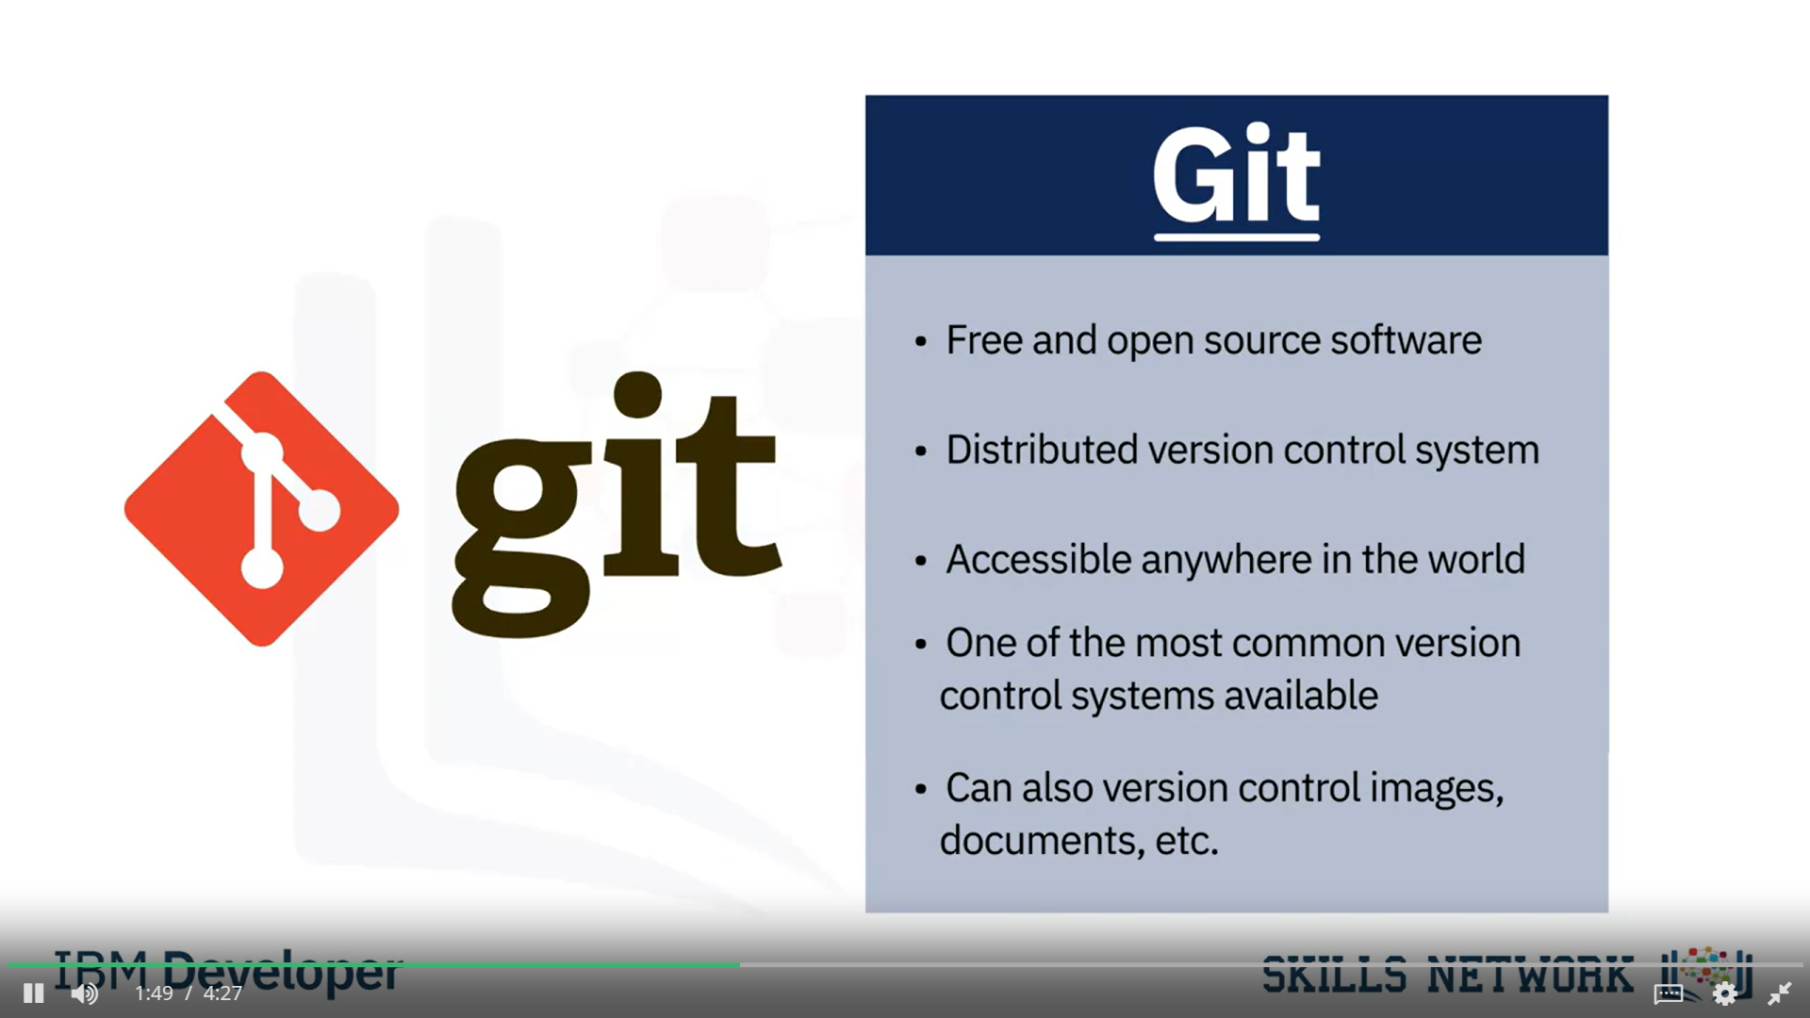

What is Git?

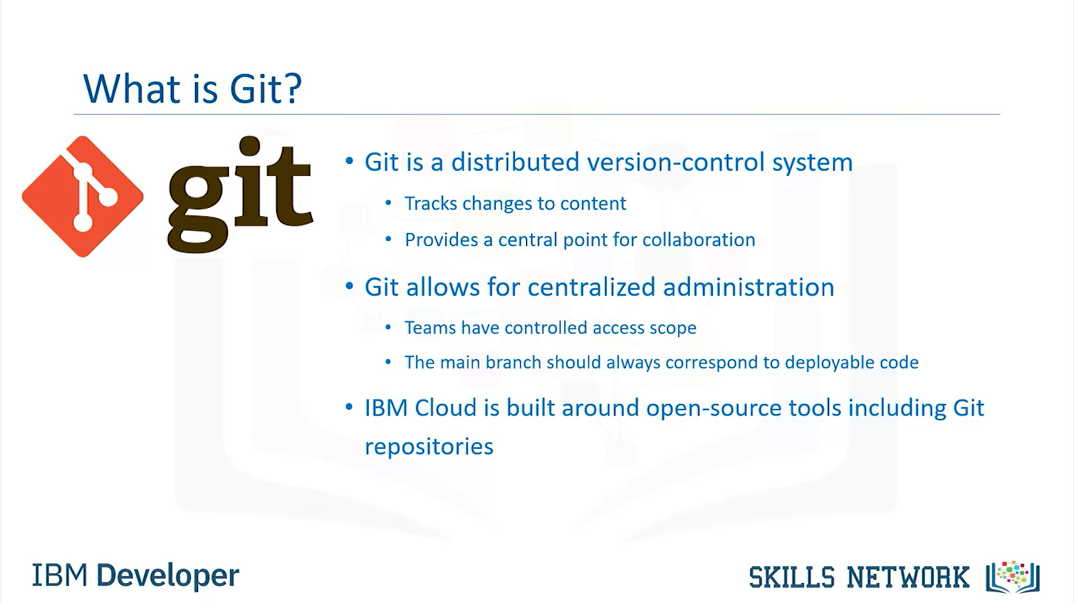

What is GitHub?

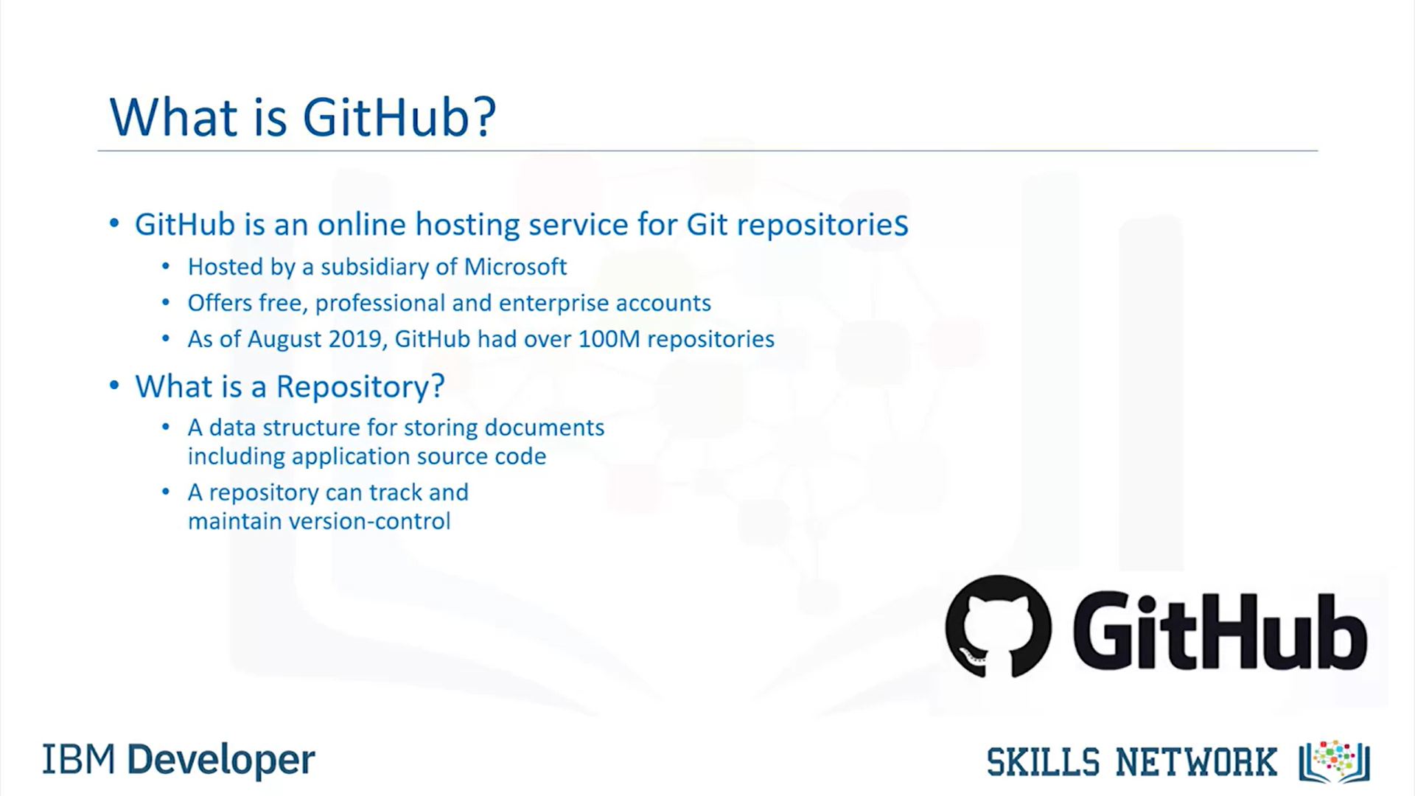

Glossary of Terms:

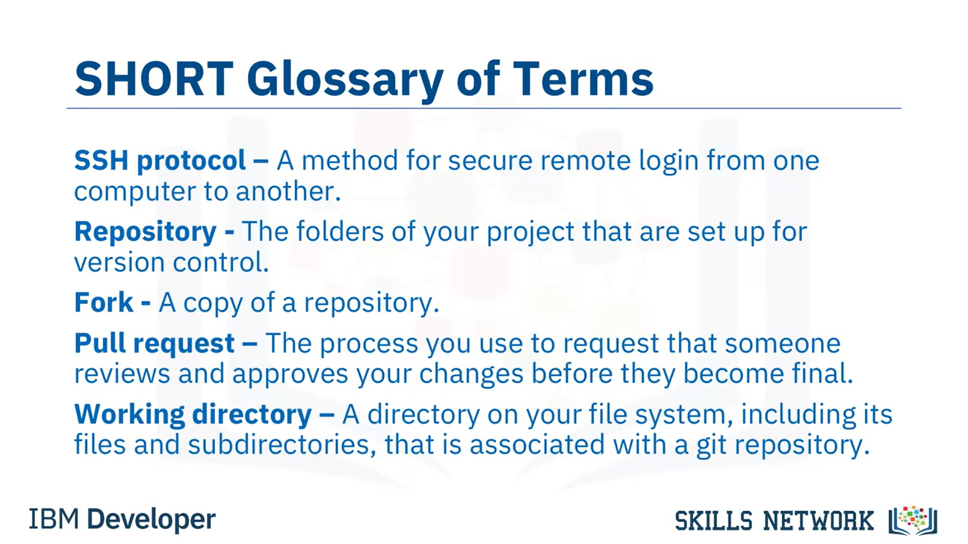

GitLab:

Basic Git Commands:

